

# Distributed Computing

**Chapter 4.1: Resource Management**



# Features of good scheduling algorithm

1. No apriori knowledge of processes
2. Dynamic scheduling
3. Balanced system performance & scheduling overhead
4. Quick decision making
5. Stability
6. Scalability
7. Fault tolerance
8. Fairness of servi

**Load balancing**

Load

Balancing

Static

Dynamic

Deterministic

Probabilistic

Centralized

Distributed

Cooperative

C

ooperati

Non-

ve

**No machine should be overloaded or under loaded.**



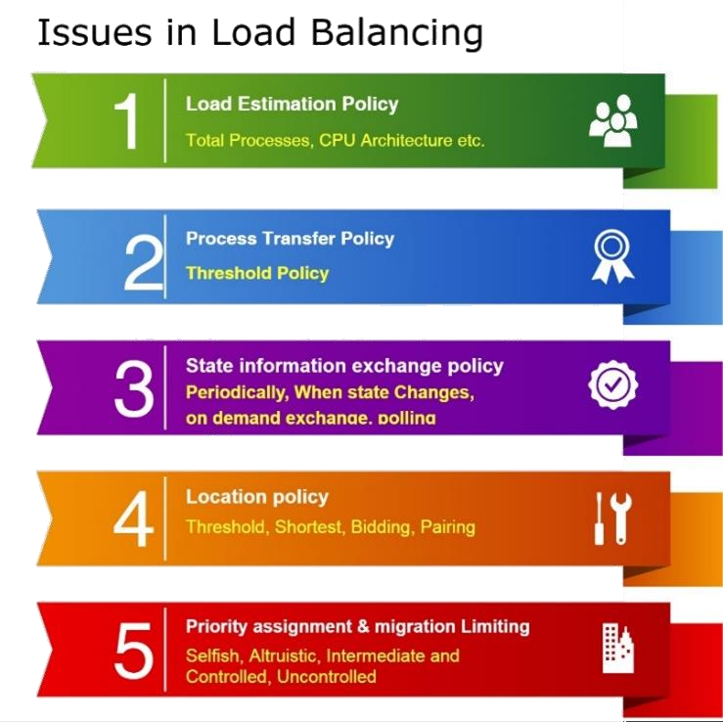

# Issues in Load balancing



**Load sharing**

**(No one should idle)**

* Load estimation policy
  + Number of processes, CPU feature
* Process transfer policy

**Issues in load sharing**

* + Sender and Receiver Initiated
* State information exchange
  + Periodically, When state Changes, Polling

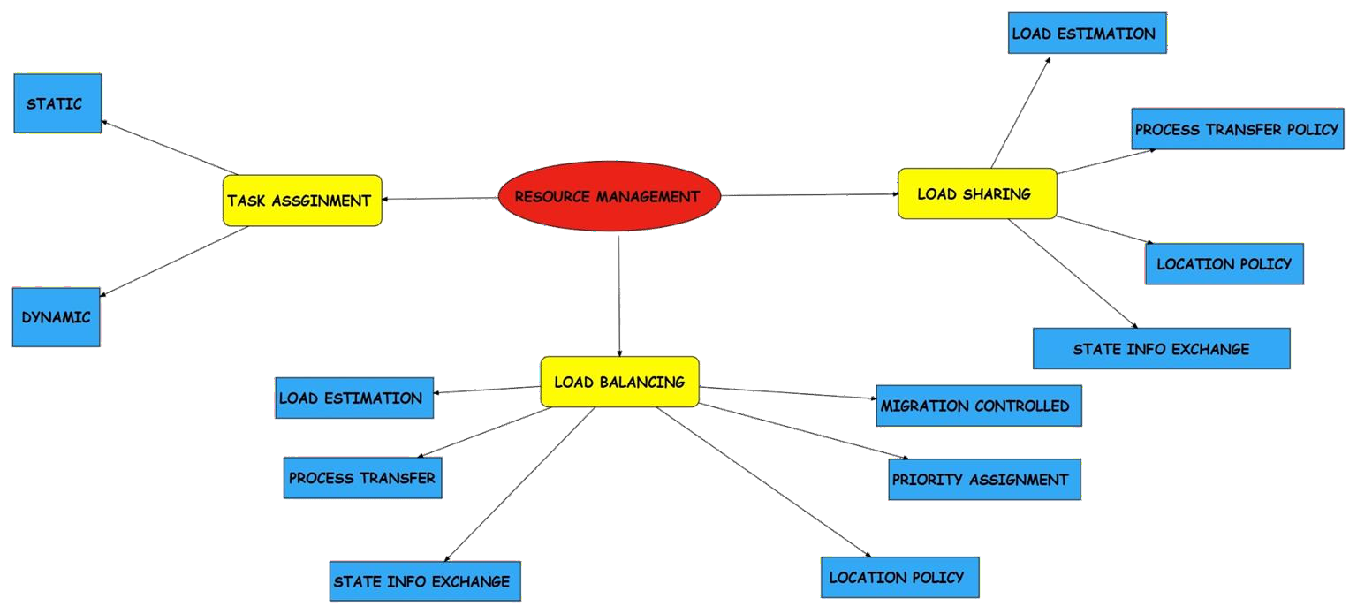

**THANK YOU !!!**